FERTILIZER SPRAYING ROBOT

Higher National Diploma in Software Engineering

Robotic Application Development

GAHDSE24.1F - 046 - J.K.N.T. Dilshan

GAHDSE24.1F - 045 - C.D. Wijesekara

GAHDSE24.1F - 044 - Ranasingha A.S

**NATIONAL INSTITUTE OF BUSINESS MANAGEMENT**

**DIPLOMA IN SOFTWARE ENGINEERING**

GA/HNDSE24.1F Robotic Application Development

**FERTILIZER SPRAYING ROBOT**

**SUBMITTED BY**

**GAHDSE24.1F - 044 - Ranasingha A. S.**

**GAHDSE24.1F - 045 - C. D. Wijesekara**

**GAHDSE24.1F - 046 - J.K.N.T. Dilshan**

SUPERVISED BY

MR. SUPUN ASANGA

This project has been proposed to partially solve the challenges and problems faced by growers in the process of fertilizer application, which is a requirement of the agricultural sector in Sri Lanka.

Group No – 15

Higher National Diploma in Software Engineering

July 18, 2024

Declaration

What we have mentioned here is the original design of our fertilizer spraying robot. We designed it under the robotic module of Mr. Supun Asanga, Our Lecturer, at the Department of Computing, NIBM University. We guarantee that the sprayer robot developed by us is the solution to the problem of spraying chemical fertilizers through the traditional method. We tried our best to improve it and hope to improve it in the future.

Group 15 - (Project Developers)

**GAHDSE24.1F - 044 - Ranasingha A. S.**

**GAHDSE24.1F - 045 - C.D. Wijesekara**

**GAHDSE24.1F - 046 - J.K.N.T. Dilshan**

07/18/2024

Table of Contents

**1.0 Abstraction 5**

**2.0 Acknowledgment 6**

**3.0 Introduction 7**

**3.1 Background and Context 7**

**3.2 Problem Statement 7**

**3.3 Objective of the project 7**

**4.0 Literature Reviews 8**

**5.0 Methodology 9**

**5.1 Components 9**

**5.2 Design and Integration 13**

**5.2.1 Hardware Assembly 13**

**5.2.2 Software Setup 13**

**5.2.3 Coding the Robot 13**

**5.2.4 Integration and Testing 13**

**6.0 Discussion 14**

**7.0 Future Implementation 16**

**8.0 References 18**

**9.0 Gantt Chart 19**

Table of Figures

**Figure 1 - Arduino Uno Board 9**

**Figure 2 - Motor Control 9**

**Figure 3 - Jumper Wires 10**

**Figure 4 - servomotor 10**

**Figure 5 - Ultrasonic Sensor 11**

**Figure 6 - Breadboard 11**

**Figure 7 - Car Kit 12**

# Abstraction

An image processing method will be used to achieve the machine's design goals. It makes it easier to choose the right sensors and devices and to detect objects. This robot will be designed using an Arduino model **based on** the image processing technique. This fertilizer spreader sprays fertilizer with efficiency and precision which can revolutionize the agriculture sector. The robot performs tasks such as identifying specific crop needs and delivering fertilizer to each plant, returning to the starting point to retrieve the fertilizer. This robot has been developed as a combination of software programming and electronic sciences. This technology can reduce the environmental effects such as the waste of labor and time required to apply fertilizers by getting rid of traditional methods. This can increase the fertility of the crops and increase the jobs through robotics, which will revolutionize the agricultural sector in the future.

In summary, the result of this is that it is possible to provide fertilizer to plants without the use of human labor by saving man's time, and it is possible to reduce the amount of fertilizer and bring about a broad revolutionary change in the agricultural sector.

# Acknowledgment

**"Helping others is more rewarding than the good we give to the world."** So, everyone in our team was equally committed to developing a fertilizer-spraying robot. Our team has done this work at Galle School of Computer Science, NIBM University. We, the team members, express our gratitude and heartfelt thanks to everyone who contributed to the production and success of this robot.

We also extend our heartfelt thanks to everyone who helped and advised us in providing the resources and facilities needed to create this Fertilizer Spraying Robot. We would also like to express our heartfelt thanks to the lecturer who guided us to make this project a success. Mr. Supun Asanga, who is in charge of the robotic module, should first be thanked and thanked. This work would have been difficult to do without him and thanks for his thoughtful and insightful answers to problems and encouragement to overcome this challenge Also friends and seniors who have helped us by word or word have helped us a lot and we should also thank them. Thanks for sharing the technical knowledge with us. We would like to thank the parents for their constant encouragement and commitment.

Finally, we thank our teacher, seniors, friends, and family who supported us in completing this project successfully, and thank you for being a part of this challenging journey.

# Introduction

## 3.1 Background and Context

There is still no progress in the agricultural sector in Sri Lanka. The traditional method of manual fertilization is still used. The traditional method is labor-intensive and time-consuming. Thus, conventional methods of fertilization cause damage to plants and waste of fertilizers. And it causes huge environmental damage and increases the cost to farmers. Robotic manure spreaders are designed to overcome these challenges. Using mechanical robots can save time, cost, and labor.

To meet these challenges, the concept of creating the robot will enable the upliftment of agriculture by using this new technology to deliver the robot by spraying fertilizer.

## 3.2 Problem Statement

A fertilizer spraying robot is an automatic mechanism designed for the proper application of fertilizers. The main objective of manufacturing this system is to ensure **"minimum human intervention".**

This gives the required amount of fertilizer to the plants at the right time. This fertilizer-spraying robot is wheeled for transportation and uses the rail concept. There are timers or automatic controls that regulate fertilizer and water for plants.

Anyone can fertilize plants on a schedule. Also controls the pipes here. Fertilizer should be applied to the plants daily as it helps the plants to grow and this helps even a busy farmer to maintain his plants.

## 3.3 Objective of the project

* The main objective of this project is as follows
* Farmers' time, labor, and costs can be saved.
* Plant damage can be minimized
* Fertilizer waste can be reduced
* Agricultural productivity can be improved and good crop yields can be obtained

# Literature Reviews

* **The implementation of the Server Motor**
* **The details of some components can be seen.**

Here are the parts related to the Pump Controlling system. Here are the parts related to the Pump Controlling system.

[https://scholar.google.com/](https://d1wqtxts1xzle7.cloudfront.net/54257387/32423-libre.pdf?1503842532=&response-content-disposition=inline%3B+filename%3DSmart_Wireless_water_level_Monitoring_an.pdf&Expires=1721291693&Signature=O2f7r6HxoSGmbSIEcVAMrqG0-rJ3Neqn28-at5H6a9Y4rfIdoxFwL1s-Z44j3eIxLCPgg~HJ3uNYT3eXefLQaa~pnX48wPH1-Io6HMLoYKJ4UXRx9EJk9oMQc2-twdi8ZNhAk2ztUD08lmMPYshN6NC5KJY-YSNSut4EIdm5UnObZprwdUmO0GUasipHBHN3FFOYDwkaaJ9vYzWjpPSVdi4~Pfigo4Tk4VGg3pl7r0qimMlJohy1ZsdtDWfI-28XO3Fo9dkNpcr131c3R2F4JapCokvhKCueTZ6mgB4bkfqzNQxqqBTEDTx2cnBcy3xKHjsdc2ggpNGW4ROwsG20OA__&Key-Pair-Id=APKAJLOHF5GGSLRBV4ZA)

* **Investigating the ultrasonic sensor.**

Ultrasonic line following robot to detect path. Vicky Barua Department of Computer Science and Engineering, BGC Trustgram University, Chatto, Chatto, Bangladesh Shahid Udin Rahat Department of Computer Science and Engineering, BGC Trust University Bangladesh, Chattogram, Bangladesh Md. Arif Istiek Neloy Department of Computer Science and Engineering

<https://scholar.google.com/>

* **Fertilizer Spraying Drone System**

Fertilizer Spraying Review on Agriculture Drone. Prof. Ritesh Banpurkar, Amol Kishor Raut, Prajwal Pralhad Ramteke, Aniket Shivkumar Prajapati, Akash Sevaklal Gautam, Gayatri Arun Deshkar, Achal Siddharth Bambole, International Journal of Scientific Research in Management & Engineering (IJSREM) May - 2021 (ISSN: 2582-3930)

[https://scholar.google.com/](https://d1wqtxts1xzle7.cloudfront.net/89076396/fertilizer-spraying-uav-a-review-on-agriculture-drone-libre.pdf?1659019443=&response-content-disposition=inline%3B+filename%3DFertilizer_Spraying_UAV_A_Review_on_Agri.pdf&Expires=1721293310&Signature=VSRJK759DtLeQhHcpc~pjUii3mBTYdu77LIUz~CG5zffPt2iZG-EcTQ0MWsQuajusob4pqftY0cG69guJNTlSlx6OsT~byle3wlWUxkF06qPVV7LxVvFSbE1neR3f6YHY1rqM4tSW2mG~F0PG6yPHYk~dtxvpG7o~6dq7Acub4escnbgTRx-EZohV5Y8H0P0sKdp-QbGDw1ZZt8fYRFsPgtNrgvLLbzCNd8gBFNM~ljxFnA3MZMS6569NsnYlMAcAJTe279Q5cDGl08WfbgQsBfY5nRbIHi4XGIFfMhsrX0Ugs2Z1qBxVWbUFRUpwdoPJj43q8MpjF9vMO-UJ83N~w__&Key-Pair-Id=APKAJLOHF5GGSLRBV4ZA)

* **Arduino Uno and Relay Module**

Arduino Uno Microcontroller and Relay Module

(Nanang Sadikin1 Marliana Sari2 Busye Sanjaya3 1,3Universitas Islam Attahiriyah. Jalan Kampung Melayu Kecil III No. 15 Jakarta. 2 Politeknik Negeri Medan. Jalan Almamater No 1 USU, Medan.)

[https://iopscience.iop.org/](https://iopscience.iop.org/article/10.1088/1742-6596/1361/1/012035/pdf)

* **The hardware of the Robot**

Through this literature review, we were able to find out the details of some components and what functions they perform.

[PDF][**Design and Implementation of a Smart Mobile Robot with Living Organisms Detection for Fire Extinguishing in Closed Areas Based on GSM**](https://easychair.org/publications/preprint_download/x5DW)

# Methodology

## 5.1 Components

The robot uses hardware and software in its design and the details of the devices used are given below

* **Arduino Uno board**

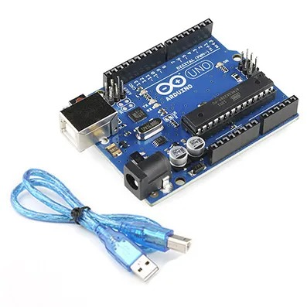Arduino Uno is a microcontroller board. It has analog input/output pins, and USB connections. This is used to control the communication between any components and implement the control algorithm.

Figure 1 - Arduino Uno Board

* **Motor Control**

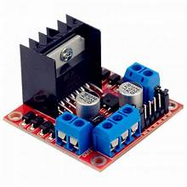Motor controllers are devices that regulate the operation of an electric motor. This is the operation of the prime mover.

Figure 2 - Motor Control

* **Jumper Wires**

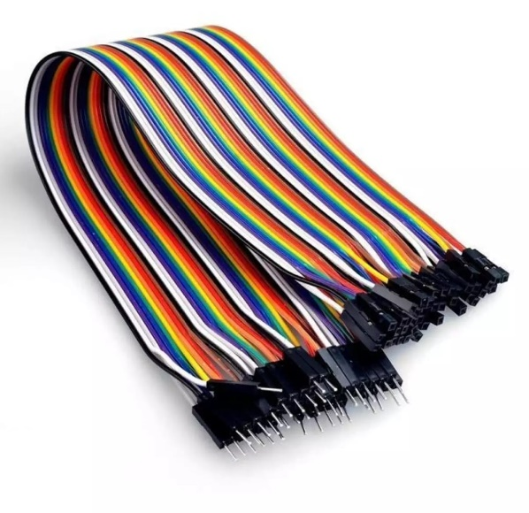A jump wire is a group of wires or cables, usually a connector used to connect the internals of a breadboard or other prototype or test circuit.

Figure 3 - Jumper Wires

* **Servo Motors**

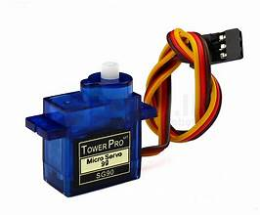A servomotor is a linear actuator that controls the velocity, linear position, and acceleration of a mechanical system.

Figure 4 - servomotor

* **Ultrasonic sensor**

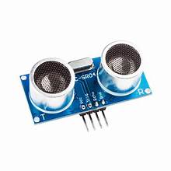This is a component that measures the distance to an object. A transducer is used to send an Ultrasonic sensor. Receive ultrasonic pulses that return information about the proximity of an object.

Figure 5 - Ultrasonic Sensor

* **Breadboard**

This is the essential foundation for building and prototyping electronics. A breadboard can easily and quickly create temporary electronic circuits.

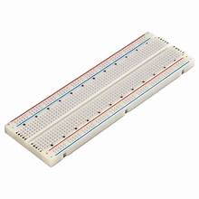

Figure 6 - Breadboard

* **Car Kit**

This robot kit includes components such as chassis, and wheels.

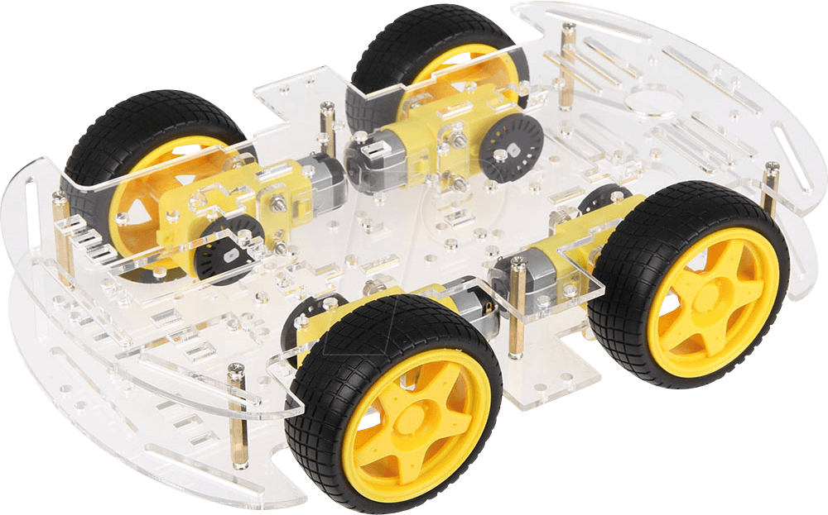

Figure - Car Kit

## Design and Integration

### Hardware Assembly

This involves assembling all the hardware, equipment, etc. required to build the robot. Arduino Uno, the motor controller, and the Ultrasonic Sensor, the server motor & the breadboard and connect them with jump wires. All of these components are connected in a given format using Arduino IDE and Proteus. We had to change some of the hardware we selected. When it came to assembling the hardware, we had to purchase several accessories between the ones we had and the ones our preacher gave us. The unity of the three in the team made it easy for us to assemble the hardware.

### Software Setup

To get a rough idea about our robot, the design was created in the Proteus software using all the relevant devices. After that, downloaded the software libraries required for coding. The software required for implementation is Arduino IDE.

### Coding the Robot

The first thing we did while coding was to keep separate files. After that, type a separate code related to it. We wrote separate codes to make the robot move, detect the plant, detect the path, and do the motor control. Then we checked all those codes with it. After that, the code was uploaded to the Arduino board.

### Integration and Testing

The testing part is used to verify that the required functions are performed correctly. Performed a test that combines all code sections written separately. Due to some problems, we had to redo the coding.

# Discussion

**Summary** - Although our robot can avoid obstacles, it cannot identify individual plants. This is most important for row crop growers. The robot can move along a fixed path where our fertilizer is sprayed and avoid the obstacles it encounters. But still not able to go anywhere and it is a good opportunity for future developers. Still, this robot cannot observe the nature of the soil and the nature of the plant.

**First Stage Discussion - Identification to create a robot for a specific problem**

The ideas of the three team members did not match each other when it came to finding a robot to create. We had to proceed through negotiations. Through the lecturer, we started to make the robot. Here we faced many problems. The first problem is that we first chose a firefighting robot. But as it is not practical, our lecturer gave us an idea to design other robots. That is the Fertilizer Spraying Robot that has been created now. Everyone in the group got together and we talked about how to make that robot, the reason for making that robot, the cost of making the robot, and many other things. Accordingly, we took steps to create the robot.

**Second Stage Discussion - Requirement Analysis and Designing**

We drew the design of the Proteus software and based on that added the price of the accessories related to these robotic products and purchased the required accessories. Our lecturer also helped us there. We got a lot of help from parents to find the equipment we could find. After presenting the proposal made by it, the lecturer approved the proposal, so we started to design the robot. The literature reviews were examined and the problems related to the creation of the robot were identified and solutions were obtained. It enabled access to devices and their related information.

**Third Stage Discussion - Implementation (Coding) & Testing)**

Coding is the hardest part. After creating the prototype, we faced many problems in our codes. Because the code to match the Proteus design does not work properly when working in real-time. Here the biggest problem we faced was that the Arduino board was not working. The Arduino board we got from the university didn't work, so we had to find our own Arduino board. Coded after that, most of the time the jump wires did not work, so I had to write the code again. Sometimes the team members could not join, so there were many challenges to do it right. We couldn't find the plant detection circuit, so we used the Rail tracks system. We were more inclined to use it to prevent the robot from moving around. The next problem is to provide different voltages of electricity to each location. The Motor Controller and Relay module are used to prevent circuit damage due to high voltages. Wrote separate codes for different sections. But sometimes they didn't work when adding all the codes. Sometimes the robot worked perfectly but sometimes the robot didn't work perfectly. This made it very difficult to work according to the timeline. Sometimes the robot moves smoothly but sometimes the Fertilizer spraying part does not work. It was very difficult for us to recognize the other person's coding when all three of the team were coding So, we used GitHub together for code sharing. **“If there is a weakness in a single device while making this robot, the entire robot has to be tested and it takes a lot of time.”** We had to face this because of the weaknesses of some jump wires. Because the robot doesn't move, we missed all the other coding parts. But every moment we try to code this robot correctly and produce a complete product.

# Future Implementation

* **Enhanced Sensor Integration:**

Improve and integrate devices used to monitor environmental conditions such as soil nature and quality.

* **AI and Machine Learning:**

Future developers can improve this by writing algorithms to automatically make decisions and adapt to different behaviors to recognize the plant, move it to the desired location, spray fertilizer, and then return to the starting point. Also, this can improve soil water content, soil fertility, and trace soil deficiencies.

* **Wireless Communication:**

Future developers can develop this to notify users via WI-FI or Bluetooth. It can be developed in such a way that soil nature, soil water content, soil fertility, and the required amount of fertilizer can be measured and monitored over the phone.

* **Weather Resistance:**

Designing circuits to adapt to the changing weather conditions in Sri Lanka as some devices may not work when monitoring soil conditions during the rainy season.

* **Data Analytics:**

Future developers could upgrade this to the ability to store ever-changing data, which could be connected to a computer to monitor and compute data.

* **Customizable Fertilizer Dispensing:**

According to the needs of different types of plants, it can be developed to be able to spray different types of fertilizers.

* **Battery Life:**

To increase the life of the batteries, the cost of the batteries and the life of the battery can be extended through the solar charging capabilities provided by the sun's rays. This eliminates the need to replace the robot's battery.

* **Collaboration with IoT Devices:**

Providing a smart farming solution through IoT devices. It can save human time. But sometimes it will enable the man to face the side effects as well.

* **Soil Health Monitoring:**

Development to Know Soil Quality Over Time.

* **Voice Command Integration:**

Voice access for various scenarios such as operating the robot through human voice.

* **Water Management:**

Can be developed to apply water to plants that require water.

* **Safety Features:**

By adding safety features, it can be developed to bypass obstacles and move through security systems. It can also be developed to travel anywhere through security mechanisms.

* **Detailed Reporting:**

It can be developed for detailed reporting of foliage, plant, and soil conditions. It can be developed to know the health condition of the plant.

* **Energy Efficiency:**

Finding a way to consume energy through energy management techniques (solar use), electronic uses, or any other use.

* **Automated Diagnostics:**

Identifying weaknesses and problems in the foliage and soil of plants and improving them so that solutions can be provided at that moment.

# References

Hardware and Software used:

* Department of Communication & Electronics Engineering, Noida Institute of Engineering and Technology, Greater Noida. NIET Journal of Engineering & Technology (NIETJET) ‘(ISSN: 2229-5828’

Publisher: Noida Institute of Engineering & Technology,

[https://www.researchgate.net/](https://www.researchgate.net/publication/366531156_Design_and_Implementation_of_Automatic_Fire_Sensing_and_Fire_Extinguishing_Robot_using_IoT)

<https://playground.arduino.cc/>

* Smart Wireless Water Level Monitoring & Pump Controlling System

Madhurima Santra, Sanjoy Biswas, Sibasis Bandhapadhyay, Kaushik Palit.

International Journal of Advances in Engineering & Scientific Research

(ISSN: 2454-8006)

<https://scholar.google.com/>

* An ultrasonic line-following robot to identify the path - Vicky Barua Department of Engineering & Computer Science, BGC Trust University Bangladesh, Chattogram, Bangladesh Md. Arif Istiek Neloy Department of Computer Science and Engineering, BGC Trust University Bangladesh, Chattogram, Bangladesh Shahid Uddin Rahat Department of Computer Science and Engineering, BGC Trust University Bangladesh, Chattogram, Bangladesh

[https://scholar.google.com/](https://d1wqtxts1xzle7.cloudfront.net/63674976/barua-2020-ijca-92036420200618-70961-af6n8t-libre.pdf?1592546276=&response-content-disposition=inline%3B+filename%3DAn_Ultrasonic_Line_Follower_Robot_to_Det.pdf&Expires=1721293105&Signature=aRxB4ep8-NiddEEmma01wcselOlMZy8lZ9W0dkytogrcMY7iGImz8w4Gb-swDnXmpLGrGMk5WKUFsfI2Cu6w2DuSe5fs6WTgTxZnrUiW4Fe4b2JtrWbGlAo4n3JiPfLK-ZRyekkf2Zp-ADUfNnwZP50U2~LMozuzp76lV5HKBQ60H8lUHCeALJzpkBVJuNOS4FfNw2VCYHemswbo3~mCD4bVKAKWnG~rGxKisSjh1PpyQQZYq6rRPFSLTn~HLNswB~gW4AbZID0txRYK6I1d~EhjwWxmKrPa7aafj3gltBUVsXpsBVZdsqyIZdG7M-NtvClNnyuhesx-9PXuO5i8Gg__&Key-Pair-Id=APKAJLOHF5GGSLRBV4ZA)

* CONTROL DC MOTORS WITH ARDUINO: WIRING & CODE EXAMPLES. this What is Arduino, Can I Connect a DC Motor Directly to an Arduino Microcontroller, How Do You Control a DC Motor with Arduino, what is a Motor Driver Module, what Types of Motor Driver Modules for Controlling 12V Motors, Pinout of an XY-160D Motor Driver Module

[https://racheldebarros.com/](https://racheldebarros.com/projects/arduino-projects/arduino-motor-control-with-wiring-and-code-examples/)

* Understanding Relays and Their Functions

<https://teknikelektronika.com/pengertian-relay-fungsi-relay/>

# Gantt Chart